Click 2.0

Technical Reference Document

V 2.2

October 27, 2021

Click2Scan

Table of Contents

Project Summary 3

Click Project Overview 4

Click Parts 5

Input 6

CSV 6

XML 7

The XML Structures 7

Database Details 8

Transaction table 8

Click Lookup Tables 8

Charity Lookup (HTTP Request to API). 8

Click Settings 8

ServiceUrls 8

Settings 8

GiftAid Logic 10

Understanding Failures in Click 11

Possible Points of Failure Discussed 11

Click Generates files from Donations 12

Important Click Tables 13

All tables are contained within a single database named “GC_EDRMS_Dev” located on SQL server “MCFSQL” 13

Transaction table 13

Click Export Tables 14

Lookup Tables 15

Export Table and Transaction Table Mapping 16

Misc (RC_ST_EDRMS_MISC) 16

Beneficiary (RC_ST_EDRMS_IRC_BENEFICIARY) 17

IRC (RC_ST_EDRMS_IRC) 18

RRP (RC_ST_EDRMS_RPP & RC_ST_EDRMS_RPP) 19

Single Transaction 20

Revisions Log 22

# Project Summary

The Click project is an integral aspect of the Masonic Charitable Foundation’s (Hereafter referred to as MCF) digital processing of donations, it’s purpose is to act as a conduit for processing and validating encrypted XML files downloaded from the donation websites and the processing of CSV files uploaded directly by Click users, these are then sent into the Relief Chest application.

There are rules, logic and workflows applicable to the processing of these records. This document is to outline these and how they fit into the procedures followed at MCF

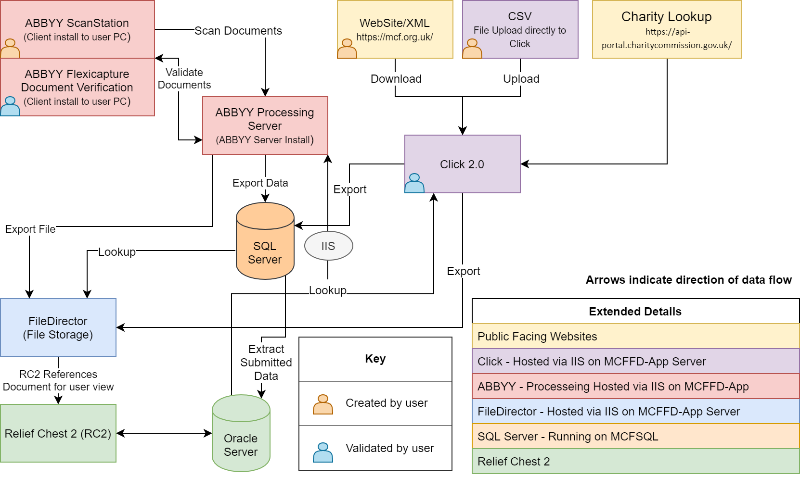

# Click Project Overview

The Click Dashboard is an internal MCF application, available internally only. It is in essence a web tool for validating information before being submitted to the Relief Chest Platform (RC2). It accepts input via downloading encrypted XML files, decrypts them and then places the contained data into the SQL server transaction tables, which acts as an organised queue for the staff at MCF to validate (Where applicable) before being transferred to its final database table with the validated details, where it is then imported by the RC2 platform. MCF Staff are also able to Create donation records via CSV files, which requires them to match very specific column structures (To be discussed further in this document), which follows the same process. Lookup now completed via Direct Oracle lookup

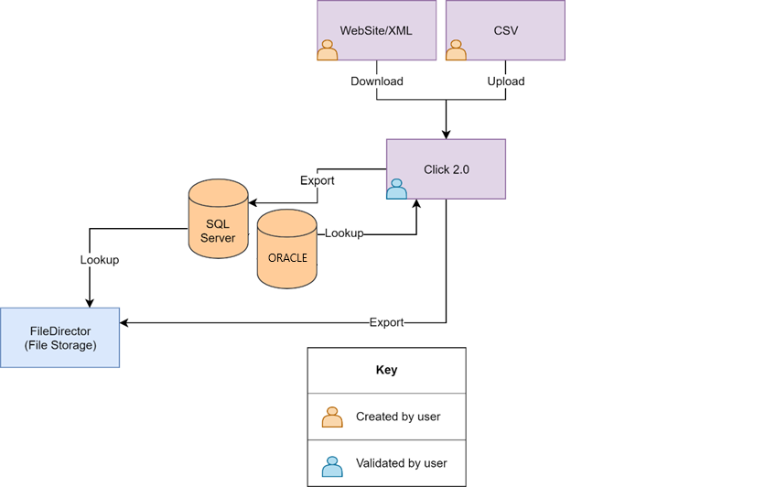

# Click Parts

The flow of data is as below

* Input
  + Via CSV
  + Downloaded from XML Web Sources
* Click (Export)
  + Exported to the transaction database
  + Or direct to exported table if certain transaction types
* Transaction Table
  + All fields and data are stored here ready for being processed from validation
* 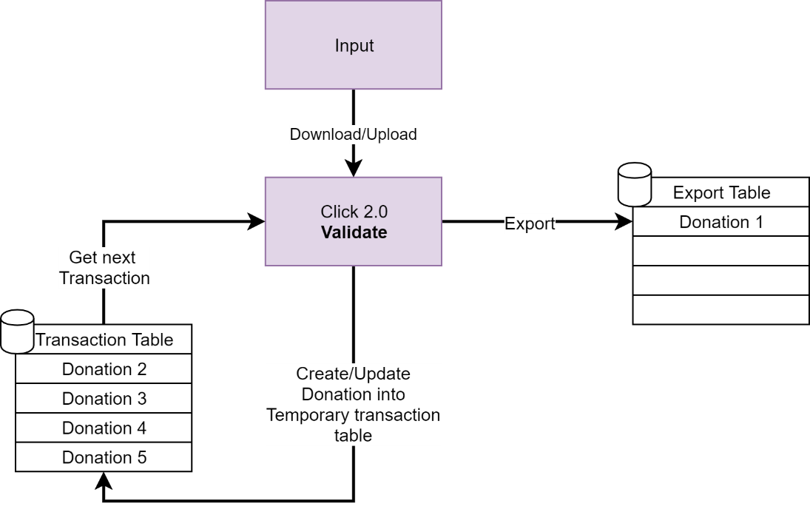Click (Validation)
  + Data verification by MCF users and lookup data for matching against stored data
* Export to exported table
  + Exported data is then picked up by RC2 platform

## Input

### CSV

There are two varieties of CSV (Comma separated values) file input able to be submitted to the Click tool, a standard transaction type which covers more fields available and a Miscellaneous transaction type which is a more specific to the requirements for the documentation. There are two options for

#### Security for the data contained

The data is created by MCF staff internally, the data is generated from a csv file by Click and stored in a database also internally stored. There is no public access to this data.

#### The CSV fields

The fields and order are as below

|  |  |
| --- | --- |
| **Standard** | **Misc** |
| Donor Salutation | Chest Number |
| Donor FirstName | Unit Number |
| Donor Last Name | Donation Amount |
| Donor Address 1 | Description |
| Donor Address 2 | Receipt Required |
| Donor County | Payment Method |
| Donor City | Donation Source |
| Donor Postcode | Lump Sum |
| Donor Country |  |
| Donation Amount |  |
| Donation Date |  |
| Gift Aid Eligible |  |
| Lodge Number |  |
| Chest Number |  |
| Chest Name |  |
| Fundraiser Full Name |  |
| Fundraiser Page Url |  |
| Cleared Funds Date |  |
| Status |  |

N.B. For DigitalDonation type, ChestName is mapped to AppealName

### XML

Data which is downloaded from the Paperless website for a variety of donation types is generated originally into XML files, which are encrypted on generation.

#### Security for the data contained

The transport mechanism to download the data file is HTTPS, this pulls down the encrypted file from an IP restricted endpoint address, HTTPS uses 256bit encryption, on top of this, the encryption used for the files generated uses 1024bit encryption, the file type is also further obfuscated by the use of a custom file extension (.knowology)

### The XML Structures

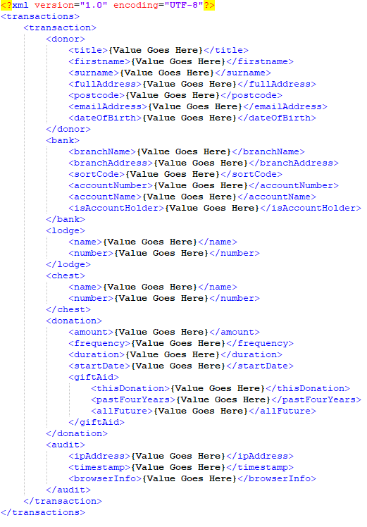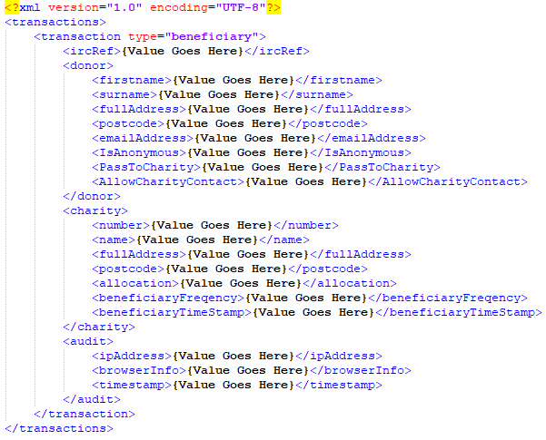IRC Beneficiary RPP

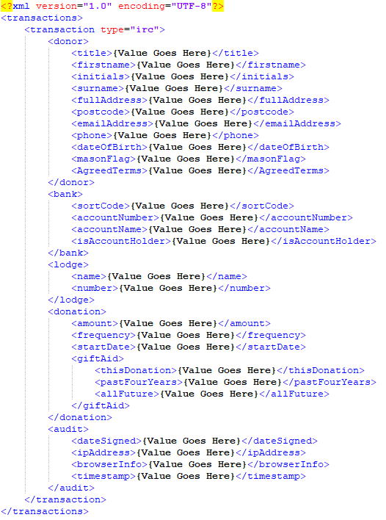

## Database Details

### Transaction table

The Transaction table is used for storing the values ready for validation. It has a large quantity of fields, all of which are not used by all transaction types. All transactions are stored here prior to being exported. Every value is mapped to one of these database fields for reference later on export. (See Appendix: Important Click Tables-> Transaction table).

### Click Lookup Tables

Click uses a number of database tables to check information from (See Appendix: Important Click Tables-> Lookup tables)

### Charity Lookup (HTTP Request to API).

The Charity lookup is completed against the Charity API offered by <https://api-portal.charitycommission.gov.uk/> (Legacy lookups used <http://opencharities.org/charities/>)

## Click Settings

Click Settings are held primarily in the ‘Setting’ table within the database (The Web apps config file holds the database connection details). It holds Key/Value pairs

There is however another table, the ‘ServiceUrl’ table holds all URL’s to the php webservices where we gather the donation XML files from.

### ServiceUrls

* ServiceUrlId
* DateCreated
* ServiceName
* ServiceUrl
* ServiceSource
* Active

### Settings

Stored in the database

|  |  |
| --- | --- |
| **SettingName** | **SettingValue** |
| ServiceListFormat | ?action=list |
| ServiceFetchFormat | ?action=fetch&file={0} |
| ServiceDestroyFormat | ?action=destroy&file={0}&hash={1} |
| PrivateKeyFile | D:\knowology\Keys\keys-private.key |
| PublicKeyFile | D:\knowology\Keys\keys-public.key |
| TimeoutAbandoned | 8 |
| PathTemp | D:\knowology\Temp |
| PathBackup | D:\knowology\Backup |
| PathRegularExport | \\publicsrv\Public\Everyone\Abbyy\Export.v9\RPP |
| PathSingularExport | \\publicsrv\Public\Everyone\Abbyy\Export.v9\GAE |
| AuditTimeToLive | 30 |
| ServiceCheckForNew | 1440 |
| EmailServerHost |  |
| EmailServerPort | 993 |
| EmailUsername |  |
| EmailPassword |  |
| CharitySearchUrl | http://opencharities.org/charities/ |
| CharityLookupUrl | http://opencharities.org/charities/term/ |
| PathMiscExport | \\publicsrv\Public\Everyone\Abbyy\Export.v9\Misc |
| IrcEmailEnabled | TRUE |
| IrcEmailPassword |  |
| IrcEmailServerHost | fmhexch10.fmh.local |
| IrcEmailServerPort | 25 |
| IrcEmailSubject | Individual Relief Chest Donation |
| IrcEmailTemplate | D:\knowology\IRC\irc_conf_email.html |
| IrcEmailUsername |  |
| IrcEmailUseSsl | FALSE |
| PathIrcBeneficiaryExport | \\publicsrv\Public\Everyone\Abbyy\Export.v9\IrcBeneficiary |
| PathIrcExport | \\publicsrv\Public\Everyone\Abbyy\Export.v9\Irc |
| IrcEmailFromAddress | reliefchest@mcf.org.uk |
| IrcEmailBccAddress | reliefchest@mcf.org.uk |
| IrcLinkTemplate | <https://mcf.org.uk/individual-relief-chest-beneficiary/?DONOR_GIVEN_NAME=#DonorFirstName&DONOR_FAMILY_NAME=#DonorSurname&DONOR_ADDRESS1=#DonorAddress[0]&DONOR_ADDRESS2=#DonorAddress[1]&DONOR_ADDRESS3=#DonorAddress[2]&DONOR_ADDRESS4=#DonorAddress[3]&DONOR_POSTCODE=#DonorPostcode&DONOR_EMAIL=#DonorEmailAddress&DOC_REF=#TransactionRef> |

## GiftAid Logic

The Gift Aid logic has been confirmed by the MCF team inline with the logic required for handling the GiftAid input to RC2. Input is normalised and calculated based on the below values

|  |  |  |  |  |
| --- | --- | --- | --- | --- |
| **Declared Type** | **Declared Value** |  | **Exported Type** | **Exported Value** |
| ThisDonation | **Y Or Yes** |  | Transaction_GA_DECL_FLAG | **Y** |
| Past Four Years | **N Or No** | **=** | Blanket_GA_DECL_FLAG | **N** |
| All Future | **N Or No** |  | Blanket_GA_DECL_FLAG_FUTURE | **N** |
|  |  |  |  |  |
| ThisDonation | **N Or No** |  | Transaction_GA_DECL_FLAG | **N** |
| Past Four Years | **Y Or Yes** | **=** | Blanket_GA_DECL_FLAG | **Y** |
| All Future | **N Or No** |  | Blanket_GA_DECL_FLAG_FUTURE | **N** |
|  |  |  |  |  |
| ThisDonation | **N Or No** |  | Transaction_GA_DECL_FLAG | **Y** |
| Past Four Years | **N Or No** | **=** | Blanket_GA_DECL_FLAG | **N** |
| All Future | **Y Or Yes** |  | Blanket_GA_DECL_FLAG_FUTURE | **Y** |
|  |  |  |  |  |
| ThisDonation | **N Or No** |  | Transaction_GA_DECL_FLAG | **Y** |
| Past Four Years | **Y Or Yes** | **=** | Blanket_GA_DECL_FLAG | **Y** |
| All Future | **Y Or Yes** |  | Blanket_GA_DECL_FLAG_FUTURE | **Y** |
|  |  |  |  |  |
| ThisDonation | **Y Or Yes** |  | Transaction_GA_DECL_FLAG | **Y** |
| Past Four Years | **Y Or Yes** | **=** | Blanket_GA_DECL_FLAG | **Y** |
| All Future | **Y Or Yes** |  | Blanket_GA_DECL_FLAG_FUTURE | **Y** |
|  |  |  |  |  |
| ThisDonation | **Y Or Yes** |  | Transaction_GA_DECL_FLAG | **Y** |
| Past Four Years | **Y Or Yes** | **=** | Blanket_GA_DECL_FLAG | **Y** |
| All Future | **N Or No** |  | Blanket_GA_DECL_FLAG_FUTURE | **N** |
|  |  |  |  |  |
|  |  |  | Transaction_GA_DECL_FLAG | **N** |
| All Others |  | **=** | Blanket_GA_DECL_FLAG | **N** |
|  |  |  | Blanket_GA_DECL_FLAG_FUTURE | **N** |

## Understanding Failures in Click

Although unhandled Errors/Issues are reported to external web service Exceptionless, which allows visibility of errors not caught by the platform in a secure environment accessible to Click2Scan staff, this is proactively monitored by Click2Scan. There is an extensive logging system in Click which is available via the ‘Audit’ menu option, where the logs can be searched. It can show basic level of information (Show Friendly Errors), it can be expanded in the view option or by removing the friendly error option where it will give more specific errors inline with the others shown.

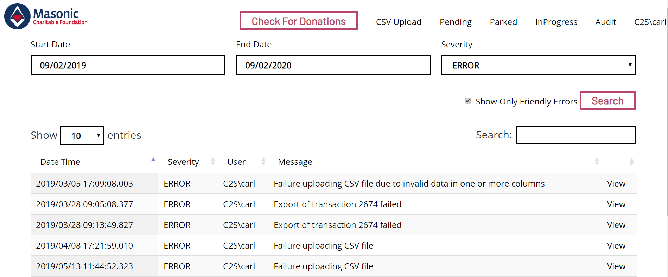

### Possible Points of Failure Discussed

The most likely points of failure that would stop Click from continuing to process, would come from a resource not being available or from an input being incorrectly formatted. Although every effort is taken to handle as many perceivable eventualities the below resources are required to function to provide a working platform.

#### Resources

**IIS** (Running from the MCF App server) - hosts the MVC Click platform written in C#

**SQL Server** - All data including logs reliant on this to be running.

**Oracle Database** – All lookups with the exception of Charities, look up against this source

**MCF Charity Donation Site** (Wordpress website) - Customers creates donations on the website, the website stores this data in a folder on the Wordpress website in encrypted XML.

**Charity Commission lookup API** - Used to fetch charity details in Clicks charity website

## Click Generates files from Donations

Click Generates a Pdf file from donations processed, these are sent to a folder which FileDirector extracts from. This is completed following a validation by the user that the data entered is correct. The document generated shows an XML style presentation of the original submitted details from the donation source. Other parts of the page include details to highlight aspects about the donation. When the document is stored, FileDirector using an import process monitors the folder for new arrivals, upon import, it finds the donation data, which is drawn from the database tables and stored to fields within FileDirectors own indexing.

To align the stored documents with RC2, the export process in Click generates a unique identifier, names the file this and exports along with the donation data, Filedirector can then based on the name of the file extract the data from the database and RC2 in turn can create a link for the user which searches for that document reference within FileDirector.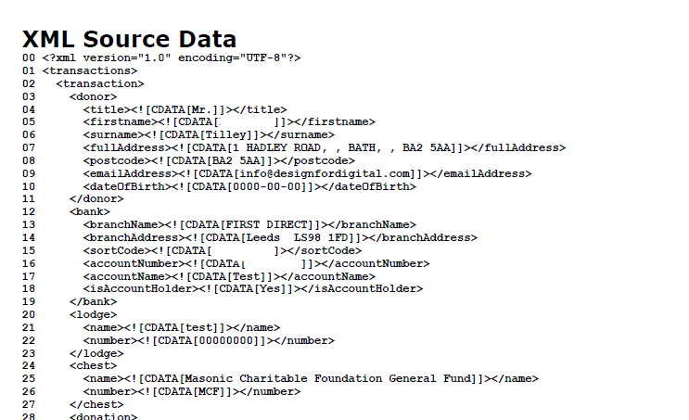Appendix

## Important Click Tables

### All tables are contained within a single database named “GC_EDRMS_Dev” located on SQL server “MCFSQL”

### Transaction table

|  |  |
| --- | --- |
| Transaction Table | |
| TransactionID | Notes |
| Status | OverrideLodge |
| LastUpdated | DonationType |
| MasonicID | Description |
| DonorTitle | ReceiptRequired |
| DonorFirstName | LumpSum |
| DonorSurname | TransactionTypeId |
| DonorFullAddress | CharityName |
| DonorPostcode | CharityContact |
| DonorEmailAddress | CharityAddress |
| BankBranchName | CharityPostcode |
| BankBranchAddress | CharityFrequency |
| BankSortCode | Defer |
| BankAccountNumber | DonorInitials |
| BankAccountName | DonorDateOfBirth |
| BankIsAccountHolder | Phone |
| LodgeName | CharityRegNumber |
| LodgeNumber | MasonFlag |
| ChestName | IsDonorAnonymous |
| ChestNumber | PassDonorToCharity |
| DonationAmount | AllowCharityContactDonor |
| DonationFrequency | DonorAgreedTerms |
| DonationDuration | RelatedTransactionRef |
| DonationStartDate | TransactionRef |
| DonationGiftAidThisDonation | ExportedDocRef |
| DonationGiftAidPastFourYears | AutoGenerateDonorFlag |
| DonationGiftAidAllFuture | CsvFileId |
| AuditIPAddress | OverrideCharity |
| AuditTimestamp | OverrideCharitySource |
| AuditBrowserInfo | LogIdentifier |
| PaymentMethod | CreatedBy |
| Source | Beneficiary_Frequency |
| XmlSourceData | Beneficiary_Timestamp |
| OverrideGiftAid | AppealName |

### Click Export Tables

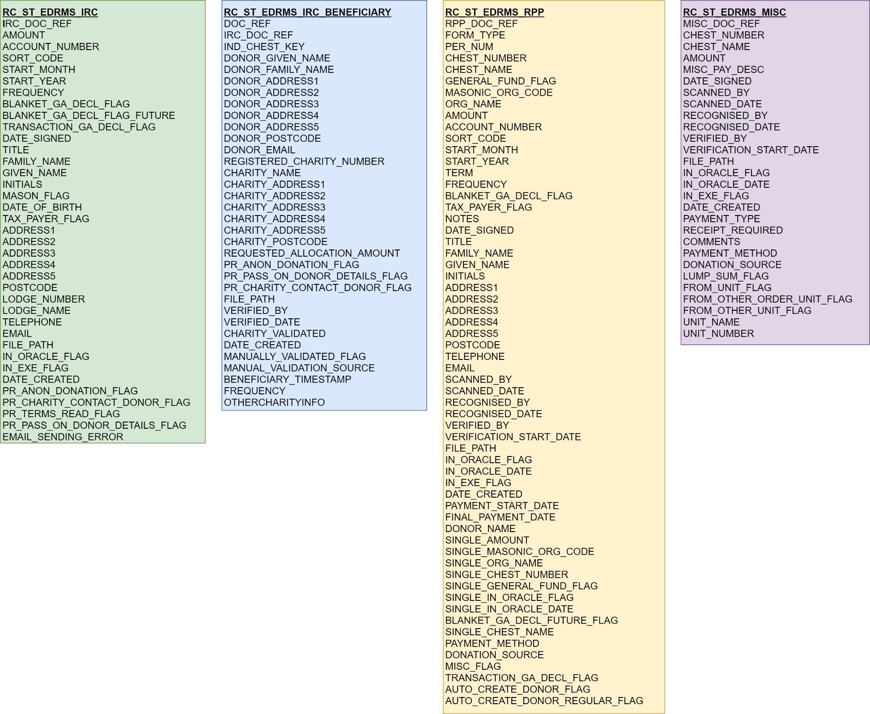

**Amendments made to Click Export Tables:** Addition of ‘AppealName’ to table ‘RC_ST_EDRMS_RPP’

### Lookup Tables

#### Chest Lookup (RC_CHEST_LOOKUP) (NOW Completed directly to Oracle Database Controlled by MCF, the fields should be the same)

* CHEST_ID
* CHEST_NUMBER
* CHEST_NAME
* DATE_CREATED
* PROVINCE

#### Lodge Lookup (RC_LODGE_LOOKUP) (NOW Completed directly to Oracle Database Controlled by MCF, the fields should be the same)

* ORG_ID
* MASONIC_ORG_CODE
* ORG_NAME
* PROVINCE
* DATE_CREATED

#### Member Lookup (RC_MEMBER_LOOKUP) (NOW Completed directly to Oracle Database Controlled by MCF, the fields should be the same)

* OWNER
* FAMILY_NAME
* GIVEN_NAME
* POSTCODE
* BLANKET_GA_DECL_FLAG
* PER_NUM
* ADDRESS1
* ADDRESS2
* ADDRESS3
* ADDRESS4
* ADDRESS5
* TITLE
* INITIALS
* DOB
* LODGE_LIST
* BANK_ACC
* SORT_CODE
* UPPER_GIVEN_NAME
* UPPER_FAMILY_NAME
* DATE_CREATED

## Export Table and Transaction Table Mapping

### Misc (RC_ST_EDRMS_MISC)

|  |  |
| --- | --- |
| **Exported Table (RC_ST_EDRMS_MISC)** | **Transaction Table** |
| UNIT_NAME | **LodgeName** |
| UNIT_NUMBER | **LodgeNumber** |
| MISC_DOC_REF | *urn* |
| FILE_PATH | *{urn}.pdf* |
| CHEST_NUMBER | **ChestNumber** |
| CHEST_NAME | **ChestName** |
| AMOUNT | **DonationAmount** |
| MISC_PAY_DESC | **Description** |
| DATE_SIGNED | **AuditTimestamp** |
| SCANNED_BY | *username (Click Username)* |
| SCANNED_DATE | *Current Date and Time* |
| RECOGNISED_BY | *username (Click Username)* |
| RECOGNISED_DATE | *Current Date and Time* |
| VERIFIED_BY | *username (Click Username)* |
| VERIFICATION_START_DATE | *Current Date and Time* |
| IN_ORACLE_FLAG | *'N'* |
| IN_ORACLE_DATE | *null* |
| IN_EXE_FLAG | *'N'* |
| DATE_CREATED | *Current Date and Time* |
| PAYMENT_TYPE | **DonationType** |
| RECEIPT_REQUIRED | **ReceiptRequired** |
| COMMENTS | **Notes** |
| PAYMENT_METHOD | **PaymentMethod** |
| DONATION_SOURCE | *Telephone* |
| LUMP_SUM_FLAG | **LumpSum** |

### Beneficiary (RC_ST_EDRMS_IRC_BENEFICIARY)

|  |  |
| --- | --- |
| **Exported Table (RC_ST_EDRMS_IRC_BENEFICIARY)** | **Transaction Table** |
| DOC_REF | *urn* |
| FILE_PATH | *{urn}.pdf* |
| DONOR_GIVEN_NAME | **DonorFirstName** |
| DONOR_FAMILY_NAME | **DonorSurname** |
| DONOR_POSTCODE | **DonorPostcode** |
| DONOR_EMAIL | **DonorEmailAddress** |
| PR_ANON_DONATION_FLAG | **IsDonorAnonymous** |
| PR_PASS_ON_DONOR_DETAILS_FLAG | **PassDonorToCharity** |
| PR_CHARITY_CONTACT_DONOR_FLAG | **AllowCharityContactDonor** |
| BENEFICIARY_TIMESTAMP | **Beneficiary_Timestamp** |
| FREQUENCY | **Beneficiary_Frequency** |
| OTHERCHARITYINFO | **Notes** |
| DONOR_ADDRESS1 | *Extracted from table* **DonorFullAddress** *from comma seperated values [Value 1]* |
| DONOR_ADDRESS2 | *Extracted from table* **DonorFullAddress** *from comma seperated values [Value 2]* |
| DONOR_ADDRESS3 | *Extracted from table* **DonorFullAddress** *from comma seperated values [Value 3]* |
| DONOR_ADDRESS4 | *Extracted from table* **DonorFullAddress** *from comma seperated values [Value 4]* |
| DONOR_ADDRESS5 | *Extracted from table* **DonorFullAddress** *from comma seperated values [Value 5]* |
| REQUESTED_ALLOCATION_AMOUNT | **DonationAmount** |
| CHARITY_ADDRESS1 | *Extracted from* **CharityAddress** *from comma seperated values [Value 1]* |
| CHARITY_ADDRESS2 | *Extracted from* **CharityAddress** *from comma seperated values [Value 2]* |
| CHARITY_ADDRESS3 | *Extracted from* **CharityAddress** *from comma seperated values [Value 3]* |
| CHARITY_ADDRESS4 | *Extracted from* **CharityAddress** *from comma seperated values [Value 4]* |
| CHARITY_ADDRESS5 | *Extracted from* **CharityAddress** *from comma seperated values [Value 5]* |
| CHARITY_POSTCODE | **CharityPostcode** |
| CHARITY_NAME | **CharityName** |
| REGISTERED_CHARITY_NUMBER | **CharityRegNumber** |
| CHARITY_VALIDATED | *Y* |
| DATE_CREATED | *current Date and Time* |
| VERIFIED_BY | *username (Click Username)* |
| VERIFIED_DATE | *Current Date and Time* |
| IRC_DOC_REF | **RelatedTransactionRef** |

### IRC (RC_ST_EDRMS_IRC)

|  |  |
| --- | --- |
| **Exported Table (RC_ST_EDRMS_IRC)** | **Transaction Table** |
| IRC_DOC_REF | *urn* |
| FILE_PATH | *{urn}.pdf* |
| DATE_SIGNED | **AuditTimestamp** |
| TITLE | **DonorTitle** |
| GIVEN_NAME | **DonorFirstName** |
| FAMILY_NAME | **DonorSurname** |
| INITIALS | **DonorInitials** |
| POSTCODE | **DonorPostcode** |
| DATE_OF_BIRTH | **DonorDateOfBirth** |
| TELEPHONE | **Phone** |
| EMAIL | **DonorEmailAddress** |
| MASON_FLAG | **MasonFlag** |
| PR_ANON_DONATION_FLAG | **IsDonorAnonymous** |
| PR_PASS_ON_DONOR_DETAILS_FLAG | **PassDonorToCharity** |
| PR_CHARITY_CONTACT_DONOR_FLAG | **AllowCharityContactDonor** |
| PR_TERMS_READ_FLAG | **DonorAgreedTerms** |
| EMAIL_SENDING_ERROR | *From confirmation of email Sending method* |
| ADDRESS1 | *Extracted from table* **DonorFullAddress** *from comma seperated values [Value 1]* |
| ADDRESS2 | *Extracted from table* **DonorFullAddress** *from comma seperated values [Value 2]* |
| ADDRESS3 | *Extracted from table* **DonorFullAddress** *from comma seperated values [Value 3]* |
| ADDRESS4 | *Extracted from table* **DonorFullAddress** *from comma seperated values [Value 4]* |
| ADDRESS5 | *Extracted from table* **DonorFullAddress** *from comma seperated values [Value 5]* |
| TRANSACTION_GA_DECL_FLAG | *GaDeclFlag (From GiftAid Logic applied however equivilant field is* **DonationGiftAidThisDonation)** |
| BLANKET_GA_DECL_FLAG_FUTURE | *BlanketGaDeclFutureFlag (From GiftAid Logic applied however equivilant field is* **DonationGiftAidAllFuture)** |
| BLANKET_GA_DECL_FLAG | *BlankedGaDeclFlag (From GiftAid Logic applied however equivilant field is* **DonationGiftAidPastFourYears)** |
| ACCOUNT_NUMBER | **BankAccountNumber** |
| SORT_CODE | **BankSortCode** |
| START_MONTH | *Get Month from* **DonationStartDate** |
| START_YEAR | *Get Year from* **DonationStartDate** |
| FREQUENCY | **DonationFrequency** |
| AMOUNT | **DonationAmount** |
| LODGE_NUMBER | **LodgeNumber** |
| LODGE_NAME | **LodgeName** |
| IN_ORACLE_FLAG | *'N'* |
| TAX_PAYER_FLAG | *Y'* |
| DATE_CREATED | *current Date and Time* |

### RRP (RC_ST_EDRMS_RPP & RC_ST_EDRMS_RPP)

#### Regular Transaction

|  |  |
| --- | --- |
| **Exported Table (RC_ST_EDRMS_RPP)** | **Transaction Table** |
| RPP_DOC_REF | *urn* |
| FILE_PATH | *{urn}.pdf* |
| FORM_TYPE | **Regular Donation** |
| DATE_SIGNED | **AuditTimestamp** |
| ACCOUNT_NUMBER | **BankAccountNumber** |
| SORT_CODE | **BankSortCode** |
| CHEST_NAME | **ChestName** |
| CHEST_NUMBER | **ChestNumber** |
| ORG_NAME | **LodgeName** |
| MASONIC_ORG_CODE | **LodgeNumber** |
| GENERAL_FUND_FLAG | *'0'* |
| TERM | **DonationDuration** |
| START_MONTH | *Get Month from* **DonationStartDate** |
| START_YEAR | *Get Year from* **DonationStartDate** |
| PAYMENT_START_DATE | **DonationStartDate** |
| FREQUENCY | **DonationFrequency** |
| AMOUNT | **DonationAmount** |
| DONATION_SOURCE | **Source** converted from number to text representation of the value. |
| MISC_FLAG | *null* |
| NOTES |  |
| PER_NUM | **MasonicID** |
| GIVEN_NAME | **DonorFirstName** |
| FAMILY_NAME | **DonorSurname** |
| DONOR_NAME | **DonorFirstName** + " " + **DonorSurname** |
| POSTCODE | **DonorPostcode** |
| AUTO_CREATE_DONOR_FLAG | **AutoGenerateDonorFlag** |
| PAYMENT_METHOD | **PaymentMethod** converted from number to text representation of the value. |
| ADDRESS1 | *Extracted from table* **DonorFullAddress** *from comma seperated values [Value 1]* |
| ADDRESS2 | *Extracted from table* **DonorFullAddress** *from comma seperated values [Value 2]* |
| ADDRESS3 | *Extracted from table* **DonorFullAddress** *from comma seperated values [Value 3]* |
| ADDRESS4 | *Extracted from table* **DonorFullAddress** *from comma seperated values [Value 4]* |
| ADDRESS5 | *Extracted from table* **DonorFullAddress** *from comma seperated values [Value 5]* |
| TRANSACTION_GA_DECL_FLAG | *GaDeclFlag (From GiftAid Logic applied however equivilant field is* **DonationGiftAidThisDonation)** |
| BLANKET_GA_DECL_FLAG_FUTURE | *BlanketGaDeclFutureFlag (From GiftAid Logic applied however equivilant field is* **DonationGiftAidAllFuture)** |
| BLANKET_GA_DECL_FLAG | *BlankedGaDeclFlag (From GiftAid Logic applied however equivilant field is* **DonationGiftAidPastFourYears)** |
| IN_ORACLE_FLAG | *'N'* |
| TAX_PAYER_FLAG | *'Y'* |
| SCANNED_BY | *username (Click Username)* |
| SCANNED_DATE | *current Date and Time* |
| RECOGNISED_BY | *username (Click Username)* |
| RECOGNISED_DATE | *current Date and Time* |
| VERIFIED_BY | *username (Click Username)* |
| VERIFICATION_START_DATE  APPEAL_NAME | *current Date and Time*  *AppealName* |

### Single Transaction

|  |  |
| --- | --- |
| **Exported Table (RC_ST_EDRMS_RPP)** | **Transaction Table** |
| RPP_DOC_REF | *urn* |
| FILE_PATH | *{urn}.pdf* |
| DONATION_SOURCE | **Source** converted from number to text representation of the value. |
| FORM_TYPE | **Single Donation** |
| DATE_SIGNED | **DonationStartDate** |
| SINGLE_CHEST_NAME | **ChestName** |
| SINGLE_CHEST_NUMBER | **ChestNumber** |
| SINGLE_ORG_NAME | **LodgeName** |
| SINGLE_MASONIC_ORG_CODE | **LodgeNumber** |
| SINGLE_GENERAL_FUND_FLAG | *null* |
| SINGLE_AMOUNT | **DonationAmount** |
| MISC_FLAG | *null* |
| NOTES |  |
| PER_NUM | **MasonicID** |
| GIVEN_NAME | **DonorFirstName** |
| FAMILY_NAME | **DonorSurname** |
| DONOR_NAME | **DonorFirstName** + " " + **DonorSurname** |
| POSTCODE | **DonorPostcode** |
| AUTO_CREATE_DONOR_FLAG | **AutoGenerateDonorFlag** |
| PAYMENT_METHOD | **PaymentMethod***converted from number to text representation of the value.* |
| ADDRESS1 | *Extracted from table* **DonorFullAddress** *from comma seperated values [Value 1]* |
| ADDRESS2 | *Extracted from table* **DonorFullAddress** *from comma seperated values [Value 2]* |
| ADDRESS3 | *Extracted from table* **DonorFullAddress** *from comma seperated values [Value 3]* |
| ADDRESS4 | *Extracted from table* **DonorFullAddress** *from comma seperated values [Value 4]* |
| ADDRESS5 | *Extracted from table* **DonorFullAddress** *from comma seperated values [Value 5]* |
| TRANSACTION_GA_DECL_FLAG | *GaDeclFlag (From GiftAid Logic applied however equivilant field is* **DonationGiftAidThisDonation)** |
| BLANKET_GA_DECL_FLAG_FUTURE | *BlanketGaDeclFutureFlag (From GiftAid Logic applied however equivilant field is* **DonationGiftAidAllFuture)** |
| BLANKET_GA_DECL_FLAG | *BlankedGaDeclFlag (From GiftAid Logic applied however equivilant field is* **DonationGiftAidPastFourYears)** |
| IN_ORACLE_FLAG | *'N'* |
| TAX_PAYER_FLAG | *'Y'* |
| SCANNED_BY | *username (Click Username)* |
| SCANNED_DATE | current Date and Time |
| RECOGNISED_BY | *username (Click Username)* |
| RECOGNISED_DATE | *current Date and Time* |
| VERIFIED_BY | *username (Click Username)* |
| VERIFICATION_START_DATE | *current Date and Time* |

# Revisions Log

|  |  |  |  |
| --- | --- | --- | --- |
| Summary Of Changes  (eg. Insert: New Image added to title) | Author  (Full Name) | Recorded on  (YYYY-MM-DD) | Version  (eg. V1.0) |
| Initial Document completed | Carl Spring (Click2Scan) | 2020-02-01 | V1.0 |
| -Change of Gift Aid Logic page(pg.10) to be a table instead of code representation  -Adjustments for clarity to System overview Diagram page (pg.2)  -Removal of original pages 7&9 on user interface as no requirements.  -Change of section Certificates rewritten and titled ‘Click generates files from donations’ | Carl Spring (Click2Scan) In consultation with Suhail Alam (MCF) | 2020-07-02 | V2.0 |
| Inclusion of Revisions Log &  Addition of Database name to ‘Important Click tables’ in Appedix. | Carl Spring(Click2Scan) | 2020-07-03 | V2.1 |
| - Digital Donation additions and new export field  -Change to Oracle lookups.  -Change to Charity lookups. | Carl Spring | 2021-10-27 | V2.2 |
|  |  |  |  |
|  |  |  |  |
|  |  |  |  |
|  |  |  |  |
|  |  |  |  |
|  |  |  |  |
|  |  |  |  |
|  |  |  |  |
|  |  |  |  |
|  |  |  |  |
|  |  |  |  |
|  |  |  |  |
|  |  |  |  |
|  |  |  |  |
|  |  |  |  |